FOR IMMEDIATE RELEASE
Contact: Robin Starkenburg, Digi-Star;
robin.starkenburg@digi‐star.com; 920‐568‐6231

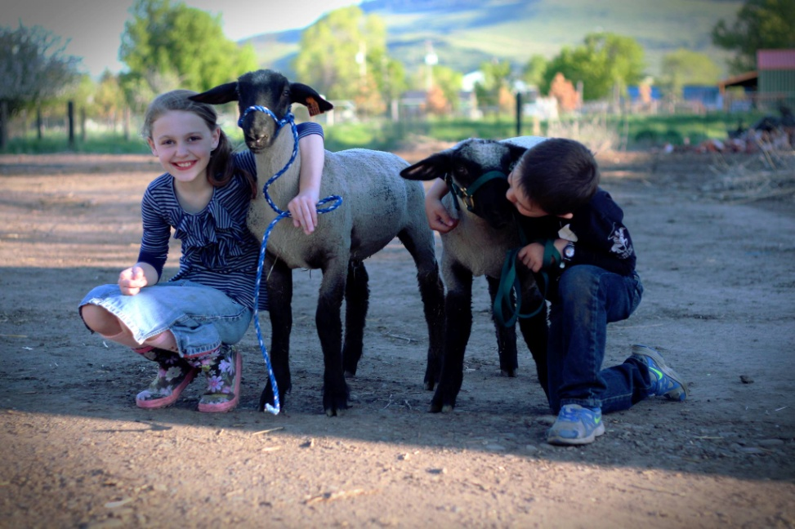
Winners selected in Be a Digi-Star Champion contest

Fort Atkinson, Wis. [July 30, 2014] – Digi-Star announces that the Hoyts of Lighthouse Rascals 4-H Club in Island City, Ore., have won the Be a Digi-Star Champion Contest. Youth livestock exhibitors entered by posting a picture or 60 second video of their 2014 livestock project to Digi-Star's Facebook page: https://www.facebook.com/DigiStarLLC.

The winning photo of Drake and Alyssa Hoyt and their market lambs received more than 1,200 likes and their prize choice was a Wrangler Jr. Livestock scale platform with a StockWeigh 300 indicator.

"It is awesome! So far we've weighed six pigs, three sheep, three dogs and all the kids! It transports easily in the back of my pick up and it's nice it only needs 2AA batteries to operate," says Justin Hoyt, Drake and Alyssa's dad.

Recognizing that access to a scale often limits weighing livestock, a key measurement process, Digi-Star developed the Be a Digi-Star Champion Contest. The contest, open to all youth under 21 exhibiting livestock during the 2014 show season, ran from May 1-June 1, 2014. Contest administrator Robin Starkenburg says, "The contest is a great opportunity for Digi-Star to connect with and show support to the future of our industry."

In an ongoing effort to support youth livestock education, Digi-Star offers specific discounts to Vo-Ag instructors for livestock scale systems purchased online at Digi-Star.com. Instructors simply need to call
800-225-7695 and request the Vo-Ag coupon code.

For more information call (920) 563-1400 or email: sales@digi-star.com.

Digi-Star LLC (http://digi-star.com/) is headquartered in Fort Atkinson, Wis., with additional facilities and businesses in the Netherlands and United Kingdom. Digi-Star LLC is a global supplier of electronic sensing equipment, precision sensors, displays and software used by farmers and other equipment operators to precisely measure and analyze valuable data from critical farming processes.
###

