FOR IMMEDIATE RELEASE
Contact: Robin Starkenburg, Digi-Star;
robin.starkenburg@digi‐star.com; 920‐568‐6231

Grain Tracker App and Grain Tracker Online available for fall harvest
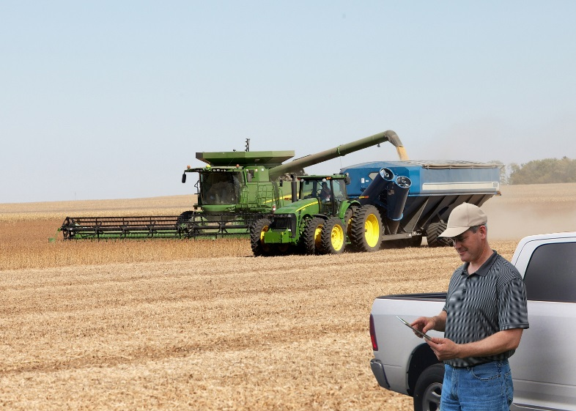
Fort Atkinson, Wis. [Sept. 2, 2015] – Digi-Star announces the release of the Grain Tracker App for iOS and Android devices, as well as Grain Tracker Online, a program that makes harvest data accessible from any internet-capable device. Grain producers using Digi-Star’s GT 460 Scale Indicator and recently released ERM Wi-Fi module can benefit from the Grain Tracker app and Grain Tracker Online this harvest season.
“These tools will provide added flexibility and precision for producers,” Digi-Star General Manager Kevin Klubertanz says. “The App lets them easily view and control their GT 460 scale indicators from their phones or tablets. Grain Tracker Online enables them to store and access harvest data from any device with internet access.”
The Grain Tracker App interfaces with the Digi-Star web server, allowing users to sync records in the Grain Tracker PC software program or the new Grain Tracker Online. The Grain Tracker App can be downloaded from any online app store. It is free of charge with the purchase of Digi-Star’s External Radio Modem (ERM) Wi-Fi module.
The ERM module is designed to transmit data to a growing portfolio of Digi-Star smartphone and tablet applications and hardware systems. Grain Tracker Online will be free to use for one year and will be available for a nominal annual fee after that.
“Combine operators can have remote control of the scale during loading to calibrate the combine yield monitor, edit field locations, change trucks and more,” Klubertanz says. “Truck drivers can easily see the weight of grain being loaded to help them maintain safe and legal road weights. We designed these products to help producers make informed decisions and eliminate guesswork for improved land management, efficiency and profitability.”

For more information about the Grain Tracker harvest system, call (920) 563-1400 or email
sales@digi-star.com. See the system live at World Dairy Expo, Sept. 29-Oct. 3, 2015 in Madison, Wis. in Exhibition Hall booths EH 1501 and 1502, Coliseum Main Concourse booth 21 and Outdoor Trade Mall booth 731.

Digi-Star LLC (http://digi-star.com/), a Topcon Positioning Group company, is headquartered in Fort Atkinson, Wis., with additional facilities and businesses in the Netherlands and United Kingdom. Digi-Star LLC is a global supplier of electronic sensing equipment, precision sensors, displays and software used by farmers and other equipment operators to precisely measure and analyze valuable data from critical farming processes.
###

