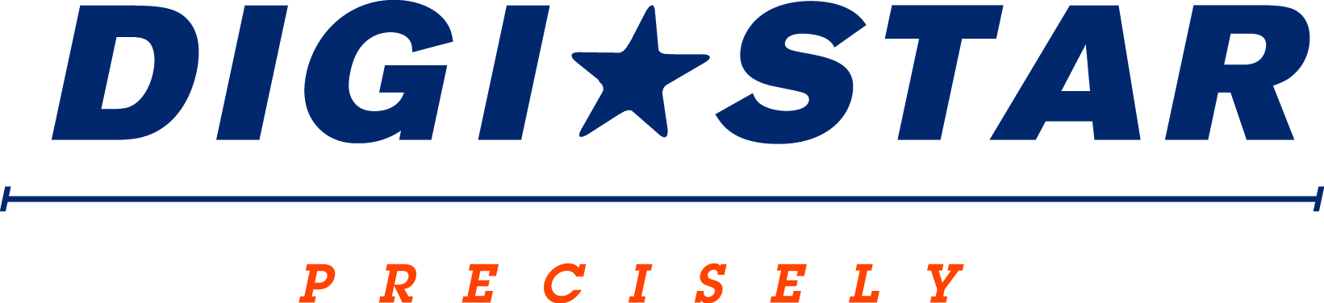

FOR IMMEDIATE RELEASE
Contact: Robin Starkenburg, Digi-Star;
robin.starkenburg@digi‐star.com; 920‐568‐6231

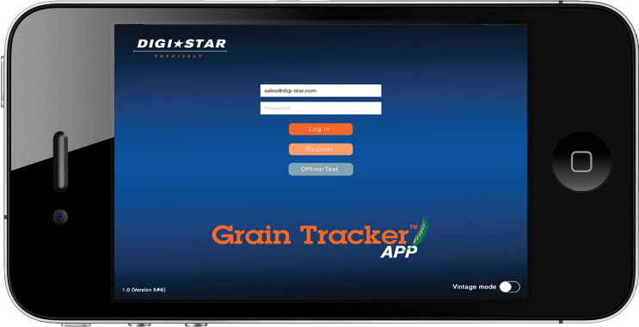
Digi-Star to introduce new Grain Tracker app

Fort Atkinson, Wis. [January 22, 2015] – Digi-Star will introduce the new Grain Tracker app at the 2015 National Farm Machinery Show held February 11-14 in Louisville, Ky.
The Grain Tracker app will give producers full functionality of the GT 460 grain cart scale system straight from their smart phone or tablet. By adding Digi-Star’s ERM-WIFI module to the GT 460, producers will be able to connect wirelessly via the app making harvest-time tasks even easier.
“Combine operators will be able to easily update and correct their yield monitor with the Grain Tracker app,” says Jerome Bump, Digi-Star senior product development manager. “Additionally, truck drivers will be able to easily see how much grain has been loaded on the truck.”
The Grain Tracker app will be available for download later in 2015. By downloading the app producers will receive a free one-year subscription to Grain Tracker Online, giving them access to their harvest records from anywhere and on any device with internet access.
Digi-Star sales manager Jack Danner says, “This full feature system will allow custom harvest teams to have billing data available as they are pulling out of the last field.”
Visit Digi-Star’s booth during the National Farm Machinery Show (South Wing B, #933-935) to learn more about the new app. For more information, call (920) 563-1400 or email: sales@digi-star.com.
Digi-Star LLC (http://digi-star.com/) is headquartered in Fort Atkinson, Wis., with additional facilities and businesses in the Netherlands and United Kingdom. Digi-Star LLC is a global supplier of electronic sensing equipment, precision sensors, displays and software used by farmers and other equipment operators to precisely measure and analyze valuable data from critical farming processes.

###

