FOR IMMEDIATE RELEASE
Contact: Robin Starkenburg, Digi-Star;
robin.starkenburg@digi‐star.com; 920‐568‐6231

Image available for download: http://bit.ly/1NCxJur

Wisconsin Lt. Governor welcomed at Topcon Tokyo headquarters

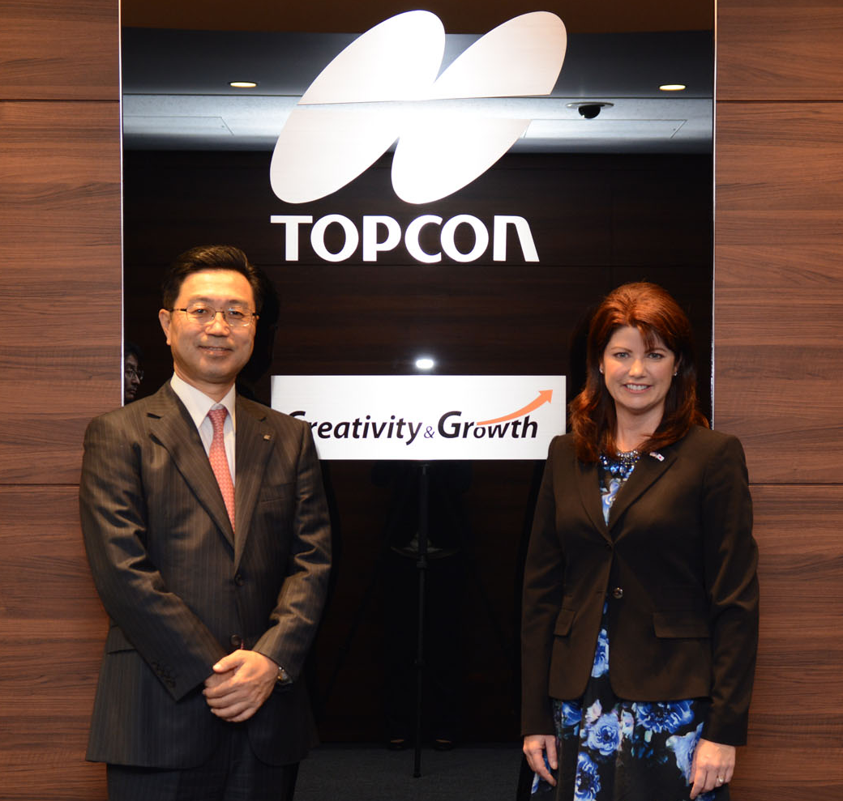
Fort Atkinson, Wis. [Oct. 16, 2015] – Digi-Star, a recently acquired Topcon Positioning Group company, announces Wisconsin Lt. Gov. Rebecca Kleefisch visited Topcon headquarters as part of a seven-day trade mission in Japan and Taiwan recently.
Steve Hirano, president of Topcon Corporation, welcomed Kleefisch and a group of executives from the Wisconsin Economic Development Corporation. The group took a tour of the facilities to learn more about its interest in precision agriculture and other Topcon technologies that might positively impact the state of Wisconsin.
"In our global economy, trade and investment with partners across the world are crucial to a strong Wisconsin," said Lt. Governor Kleefisch. "Companies like Topcon that invest in Wisconsin factories and workers are making a wise choice to bring their business to the Badger State. We appreciate their confidence in Wisconsin and its future, and we hope for their continued growth and success in our state."
Kleefisch explained that Wisconsin is putting significant effort in educational and tax benefits to attract companies to the region. Among the examples of its educational endeavors include a focus at the University of Wisconsin to attract and develop exceptional engineers.
Hirano said, “We are proud of our expansion in Wisconsin, which, at the center of the dairy and agricultural market, makes for a strategic and attractive place to invest our resources for that area of our business. We are looking forward to this collaboration and are impressed with Wisconsin’s interest in developing engineers that will create future innovations.”
The Digi-Star acquisition fits in line with one of the Topcon missions of the smart integration of information and technology to constantly improve productivity in order to create sustainable agriculture.
“Given the predicted population demands of the future, bringing the Industrial Internet of Things (IIoT) to every farm is essential to the sustainable management of the world’s resources. The Digi-Star merger helps us accomplish that goal — as well as further places us in the business of providing not only precision agriculture, but also more complete farming solutions,” Hirano said.
Along with the positioning business areas, the tour included the Topcon medical operations as well, which also drew the group’s attention for its advanced technologies.
Digi-Star LLC (digi-star.com), a Topcon Positioning Group company, is headquartered in Fort Atkinson, Wis., with additional facilities and businesses in the Netherlands and United Kingdom. Digi-Star LLC is a global supplier of electronic sensing equipment, precision sensors, displays and software used by farmers and other equipment operators to precisely measure and analyze valuable data from critical farming processes.

###

