FOR IMMEDIATE RELEASE
Contact: Robin Starkenburg, Digi-Star;
robin.starkenburg@digi‐star.com; 920‐568‐6231

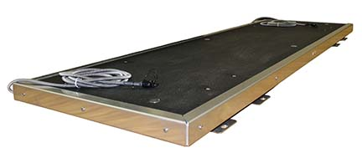

StockWeigh Low Profile Scale platform now available

Fort Atkinson, Wis. [June 24, 2015] –Digi-Star introduces the StockWeigh Low Profile Scale. This wide-platform scale comes standard with an Animat™ maximum-grip surface rubber mat, making it quieter than other scales.

“Producers have asked for a wider-based platform that is convenient and easy to clean,” says Nicole Turner, livestock technical sales representative with Digi-Star. “We responded with the StockWeigh Low Profile Scale combined with the Animat™ maximum-grip, diamond-shaped mat. The mat prevents skidding and reduces noise which cuts down on interruptions in cattle movement. It is also easy to clean or replace, making it an efficient, safe and biosecure choice in precision weighing.”

The StockWeigh Low Profile Scale easily fits into an existing squeeze chute, alleyway or grooming chute to provide flexibility, convenience and improved cattle handling. It offers two different load cell configuration options. It works with all of Digi-Star’s StockWeigh indicators including the SW4600 electronic identification (EID) recording scale, the battery-powered SW300 and the SW600.

Producers can order the new platform scale from Digi-Star’s online store or from Digi-Star’s StockWeigh Distributors.

For more information call (920) 563-1400 or email sales@digi-star.com.

Digi-Star LLC (http://digi-star.com/), a Topcon Positioning Group company, is headquartered in Fort Atkinson, Wis., with additional facilities and businesses in the Netherlands and United Kingdom. Digi-Star LLC is a global supplier of electronic sensing equipment, precision sensors, displays and software used by farmers and other equipment operators to precisely measure and analyze valuable data from critical farming processes.
###

