FOR IMMEDIATE RELEASE
Contact: Robin Starkenburg, Digi-Star;
robin.starkenburg@digi‐star.com; 920‐568‐6231
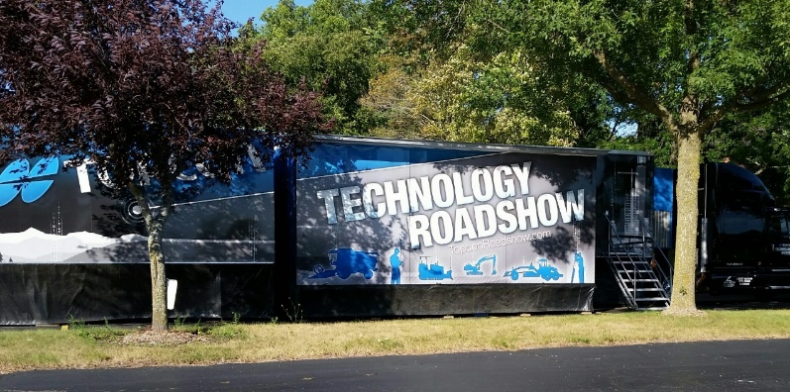

Topcon Technology Roadshow kicks off tour, annual Digi-Star University

Fort Atkinson, Wis. [August 25, 2015] – Digi-Star will be the North American agricultural hub for Topcon Positioning Group, the two companies announced today in a joint event at Digi-Star’s Fort Atkinson location. The event was the official kick-off for the first all-agricultural Topcon Technology Roadshow and is part of the annual Digi-Star University.

Digi-Star customers and guests toured the roadshow truck and had an early look at technology being unveiled at the Farm Progress Show in Decatur, Ill.

The truck is a mobile display of products and solutions from Topcon Positioning Group. While the truck has been featuring solutions for construction, geopositioning and other industries, the truck will now feature brands from Topcon Precision Agriculture including Topcon, Digi-Star, NORAC, RDS Technology and Wachendorff Elektronik.

Topcon Positioning Group acquired Digi-Star in March, making the facility the ideal starting point for the new agricultural tour, said Albert Zalhalka, president of Topcon Precision Agriculture.

“Starting the tour here in Fort Atkinson allows us to share our vision of Topcon leadership in the precision ag movement,” Zalhalka said. “We are pleased to show producers how this partnership can provide them with tools to maximize efficiency and grow profits.

Digi-Star University is held annually to help train the company’s manufacturing customers to use soon-to-be released technology.

“We are pleased to introduce the opportunities of our combined expertise with Topcon in developing sensors, GPS devices, controls and displays for the agricultural producers of the future,” said Digi-Star General Manager Kevin Klubertanz. “Digi-Star is excited about sharing this new technology with our strong base of manufacturing customers.”
Digi-Star LLC (http://digi-star.com/), a Topcon Positioning Group company, is headquartered in Fort Atkinson, Wis., with additional facilities and businesses in the Netherlands and United Kingdom. Digi-Star LLC is a global supplier of electronic sensing equipment, precision sensors, displays and software used by farmers and other equipment operators to precisely measure and analyze valuable data from critical farming processes.
###

